Chapter 11, Solution 29.

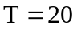, 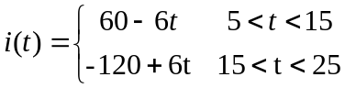

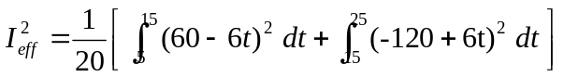
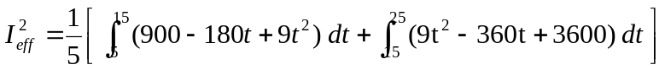
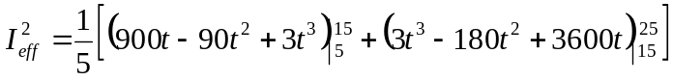
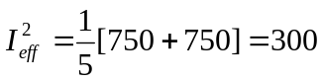

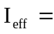17.321 A

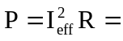(17.321)²x12 = 3.6 kW.

